Design a basic UI of an Android/iOS mobile phone app for emails.

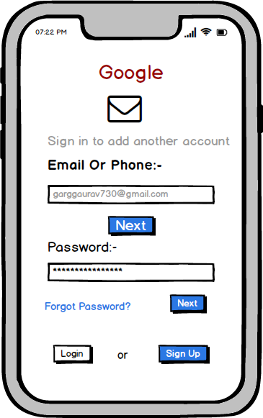

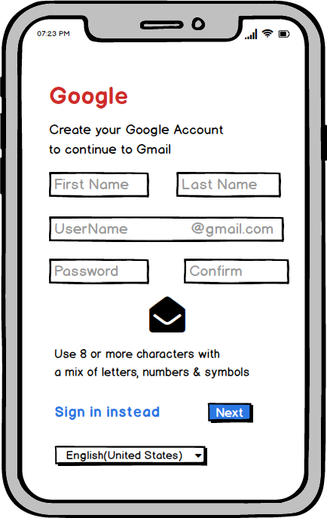

Design a basic UI of a browser for an iPad.

